***The*** ***EnergyStore***

Renewable Power Supply

CATALOG

2016

4421 Cherry Street, Suite #20

Winston-Salem, NC 27105

**Phone: 336.793.3418**

[www.theenergystorenc.com](http://www.theenergystorenc.com)



Powered by

Effective September 1, 2016

*The EnergyStore* is your local source for Renewable Power Products. We strive to provide the best quality products available today, at a reasonable price. We have over 30 years of experience in renewable energy and offer superior support for your installation. We also have a variety of Preferred Licensed Contractors available to assist with your installation or service if needed. Feel free to contact us with any questions regarding any of our products or to schedule an in home energy analysis.

**Solar Investment Tax Credit**

**What is the Solar Investment Tax Credit?**

The Investment Tax Credit (ITC) is currently a 30 percent federal tax credit claimed against the tax liability of residential (Section 25D) and commercial and utility (Section 48) investors in solar energy property. The Section 25D residential ITC allows the homeowner to apply the credit to his/her personal income taxes. This credit is used when homeowners purchase solar systems outright and have them installed on their homes. In the case of the Section 48 credit, the business that installs, develops and/or finances the project claims the credit.

**How does the Solar Investment Tax Credit Work?**

A tax credit is a dollar-for-dollar reduction in the income taxes that a person or company claiming the credit would otherwise pay the federal government. The ITC is based on the amount of investment in solar property. Both the residential and commercial ITC are equal to 30 percent of the basis that is invested in eligible property which have commence construction through 2019. The ITC then steps down to 26 percent in 2020 and 22 percent in 2021. After 2023, the residential credit will drop to zero while the commercial and utility credit will drop to a permanent 10 percent

Commercial and utility projects which have commenced construction before December 31, 2021 may still qualify for the 30, 26 or 22 percent ITC if they are placed in service before December 31, 2023. The Treasury and IRS are currently drafting guidance which will inform solar developers of which percentage of ITC they will qualify for depending on when they started their project

**Portable Power**

**30W CHARGING STATION**

1 x 30W/12V Solar Panel

**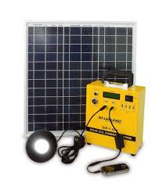**1 x Plug & Play Integrated Powerbank Cabinet Includes:

Built-in controller 10A/12V

Maintenance-Free Lead-Acid Battery 18AH/12V

LCD showing System Status including; ...Battery Voltage/Capacity & -

State of Charge/Discharge

4 x 12VDC Port

1 x 12VDC Cigarette Lighter Socket

4 x 500mA/5V USB Port

3 x SLS-M06 Phone Charger Convertors

3 x SLS-P01 Adapter Kits; suitable for popular cell phones

and other handheld devices

1 x 3W/12V LED Lamp Assembly with 5m cable, in-line

On/Off switch & lamp shade

1 x SDP-Y-4 10-in-1 USB Adapter

**TOTAL $299.00**

**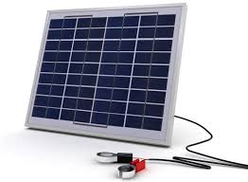10-12 Solar Battery Charger**

This 10 Watt 12 Volt DC polycrystalline solar module is designed for applications like RVing, camping, hunting and fishing. This solar panel has a blocking diode integrated into the junction box of the module and heavy duty battery clamps**.**

**TOTAL $59.00**

**40-12 Solar Battery Charger**

****This 40W 12V model is suited for 1 battery systems where energy demand is light. Can also be used for vehicles in storage to maintain batteries.

Kit Consists:

1 x SLP040-12U 40W/12V Solar Panel (27" x 22" x 1.5")

1 x SLSC-02 Elite Battery Clamp Set

1 x SLC-1203B 3A PWM Solar Controller (Loose)

1 x Cloth Carry Case

15' Cable

**TOTAL $189.00**

**Portable Power**

**80-12 Solar Battery Charger**

**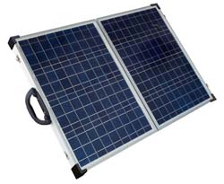**This 80W 12V model is suited for 1~2 battery systems where energy demand is light. Can also be used for vehicles in storage to maintain batteries.

Kit Consists:

2 x SLP040-12U 40W/12V Solar Panels (Hinged)

1 x SLSC-02 Elite Battery Clamp Set

1 x SLC-NR2410A PWM Controller

Waterproof Weather-Pack Connectors

1 x Soft Shell Carry Case

16' Cable w/inline Fuse

Panel Folded: 27" x 22" x 3.5" (27lbs) Panel Open: 43" x 27" x 1.5"

**TOTAL $439.00**

**120-12 Solar Battery Charger** This 120W 12V model is suited for 1~2 battery systems where energy demand is moderate. Can also be used for vehicles in storage to maintain batteries**.**

Kit Consists:

2 x SLP065-12U 60W/12V Solar Panels (Hinged)

1 x SLSC-02 Elite Battery Clamp Set

1 x SLC-1210 10A PWM Solar Controller (Mounted)

1 x Soft Shell Carry Case

16' Cable w/inline Fuse

Panel Folded: 40" x 21" x 3.5"(39lbs) Panel Open: 41" x 40" x 1.5"

**TOTAL $549.00**

**25 EXTENSION** 25 Foot Extension Cord for 40W, 80W, and 120W Solar Battery Chargers.

**TOTAL $52.90**

**500W Smart Power Manager**

Integrated Inverter 500W 120V

Solar Charger 12V 12A

AC Charger 120V 6A

USB Output (2) 5V 500mA

DC Output (2) 12VDC/5A

Choose a Battery and a Solar Module to create your own customized system.

**TOTAL $149.00**

**Solar Modules**

**12 Volt Solar Modules**

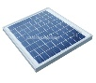

**10W Solar Module $45.00**

17.3 Vmp, 0.59 Imp, 13.8" x 11.8" x .98"

**20W Solar Module $75.00**

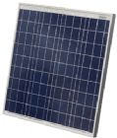17.2 Vmp, 1.17 Imp, 21.7" x 13.8" x 0.98"

**30W Solar Module $95.00**

17.49 Vmp, 1.71 Imp, 21.46" x 20.27" x 1.10"

**60W Solar Module $150.00**

18.56 Vmp, 3.23 Imp, 25.79" x 26.30" x 1.38"

**90W Solar Module $185.00**

18.0 Vmp, 5.0 Imp, 38.98”×26.18”×1.38"

**135W Solar Module $275.00**

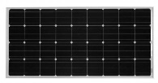18.0 Vmp, 7.5 Imp, Size: 69.0”×26.18”×1.38"

**160W Solar Module $375.00**

18.42 Vmp, 8.84 Imp, Size59.1”×26.3”×1.57"

**12 Volt Semi Flexible Modules**

Solar Flex™ panels are aerodynamic and DURABLE –

a virtually unbreakable solar battery charger for RVs, boats, [work trucks](http://gpelectric.com/fleet) and long-haul trailers and sleeper cabs. These solar panels are designed to provide a powerful charging solution for batteries and conform to almost any surface.  Unlike other ‘flexible’ products, Solar Flex™ uses high-efficiency monocrystalline cells that produce more power per square foot than any other flexible panel on the market.

**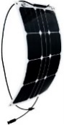30W Semi Flexible Module $156.00**

17.5 Vmp, 1.71 Imp, Size 21.6” x 14.96” x 0.01”

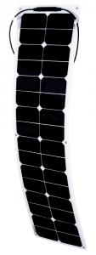**50W Semi Flexible Module $329.00**

17.5 Vmp, 2.00 Imp, Size 42.1” x 11.3” x 0.01”

**Solar Modules**

**12 Volt Semi Flexible Modules (Continued)**

**Do you need to power a fleet of work trucks or a sleeper cab?** We can help you customize a solution for any utility, long-haul or mobile office vehicle.[Contact us](http://gpelectric.com/applications/fleet-work-trucks)

**100W Semi Flexible Module $479.00**

17.5 Vmp, 5.71 Imp, Size 41.9” x 21.4” x 0.01”

**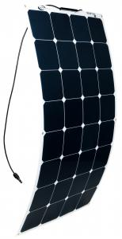**

An impermeable lamination coats the entire module, allowing it to contour and flex against curved areas, eliminating any need for custom mounts. The panel can be affixed by adhesive or screw mounting options and grommets are an added bonus for ease-of-installation. The thin, lightweight module  (modules are 82% lighter) can also be sewn into canvas, making it a truly versatile solar module.

Sealant/adhesive will depend on roof membrane material and is not included in Solar Flex kit. Use an appropriate sealant as recommended by your RV Dealer or manufacturer.

**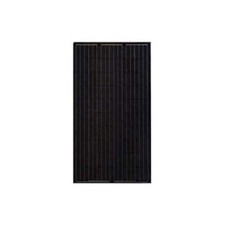24Volt Solar Modules**

**Suniva OPT280-60-4-BO $420.00**

**280W Black**

**Suniva OPT280-60-4-100 $350.00**

**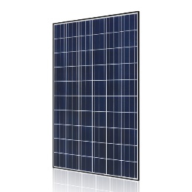280W Clear**

**Hyundai HIS-M260RG(BF) $275.00**

**260W Clear**

**REC310PE72 $387.50**

**310W Clear**

**\* Module Brands and price subject to change without notice.**

**Contact us for current availability.**

**Solar RV Kits**

**SLRV-100K** **Sun Wanderer 100w RV Roof Top Starter Kit**

**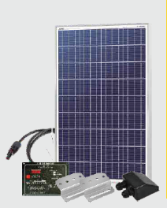**The Sun Wanderer 100w RV roof kit contains:

1 x SLP100U-12 Solar Panel w/ MC4 Cables

1 x SLC-SC30 Blue Sky Energy 30A PWM Flush Mount RV Controller

1 x SLCBL-04 MC4 Cable (50 feet)

1 x SLB-0102 Z Bracket Mount feet (4 pack)

1 x SLCBL-52 Black ABS Cable Gland

**TOTAL $499.00**

**SLRV-150K** **Sun Wanderer 150w RV Roof Top Starter Kit**

**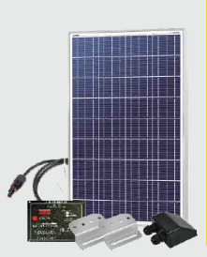**The Sun Wanderer 150w RV roof kit contains:

1 x SLP150U-12 Solar Panel w/ MC4 Cables

1 x SLC-SC30 Blue Sky Energy 30A PWM Flush Mount RV Controller

1 x SLCBL-04 MC4 Cable (50 feet)

1 x SLB-0102 Z Bracket Mount feet (4 pack)

1 x SLCBL-52 Black ABS Cable Gland

**TOTAL $590.00**

**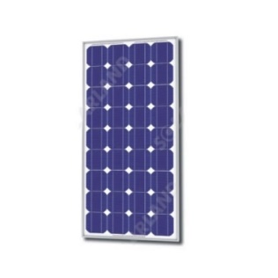**We offer a convenient expansion kit to be coupled in parallel with the Sun Wanderer Kits. You can add 3 x SLVR-100KEX Expansion Kits or 2 x SLRV-150KEX Expansion Kits without requiring an additional controller. The Blue Sky SLC-SC30 can handle up to 450W total input.

Kit Contents:

1 x SLP150U-12 or 1 x SLP100-12 Solar Panel w/MC4 Cables

1 x SLCBL-04 MC4 Cable (50 Feet)

1 x SLB-0102 Z Bracket Mount

1 x SLCBL-52 Black ABS Cable Gland

**TOTAL**

**SLRV-100KEX Expansion Kit: $298.00**

**SLRV-150KEX Expansion Kit: $338.00**

**Off-Grid / Backup**

**Survivor Series 1000GA-P**

SL Foldable 80W 12V Module Kit w/Charge Controller

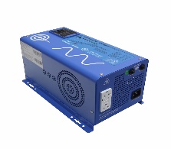AIMS 1000W PSW Inverter/Charger

8A24DT 12V 79A AGM Battery

Battery Box (Strong Box) White

#2 Battery Wiring Kit

MANL 80A Fuse Kit with120A DC Disconnect

USB Kit

12V Outlet

**TOTAL** **$1450.00**

**Survivor Series 1500GA**

(2) SunVolt Power 135W 12V Modules

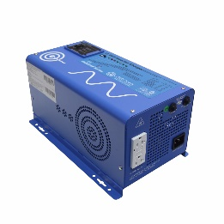MNBRAT PWM Charge Controller 20A 12V

SolaTOP 150-2 Pole/Roof Mount

AIMS 1500W PSW Inverter/Charger

8A31DTM 12V 105A AGM Batteries

Battery Box (Quick Box) Black

#2 Battery Wiring Kit

ANL Fuse Kit with120A DC Disconnect

50' PV Wiring Kit

PV Breaker Kit

**TOTAL $1990.00**

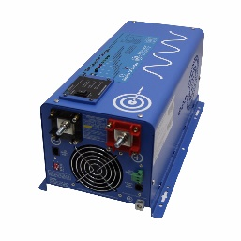**Survivor Series 2000GA**

(2) Suniva 275W Solar Modules

MNBRAT PWM Charge Controller 20A 12V

SolaTOP 300-2 Pole/Roof Mount

AIMS 2000W PSW Inverter/Charger

Battery (8A4DLTP 200AH 12V)

MNBE-B Battery Enclosure

#2/0 Battery Wiring Kit

175A DC Disconnect

50' PV Wiring Kit

PV Breaker Kit

**TOTAL $3450.00**

**Add a PRIMUS, 1-ARXM-15-12 or24, AIR-X MARINE WIND TURBINE 400 Watt Kit to any Survivor Series OG/Backup System for only; $1475.00**

\* Wire & Pole not included.

**Off-Grid / Backup**

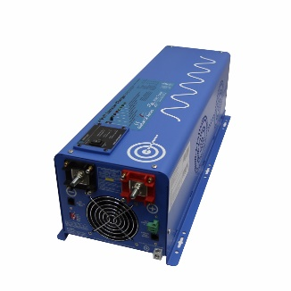**Survivor Series 4000GA**

(2)Suniva 275W Solar Modules

Morningstar 30W PWM Charge Controller

SolaTOP 300-2 Pole/Roof Mount

PICOGLF40W24V120V Inverter/Charger

(4) Battery (8AGC2 200AH 6V)

MNBE-A Battery Enclosure

#2/0 Battery Wiring Kit

250A DC Disconnect

50' PV Wiring Kit

PV Breaker Kit

**TOTAL $4490.00**

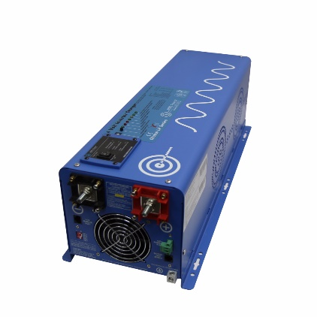

**Survivor Series 6000GA**

(2)Suniva 275W Solar Modules

MN KID 30A MPPT Charge Controller

SolaTOP 300-2 Pole/Roof Mount

PICOGLF60W24V240VS Inverter/Charger

(4) Battery (US 305 AGM 6V)

MNBE-D Battery Enclosure

#4/0 Battery Wiring Kit

250A DC Disconnect

50' PV Wiring Kit

PV Breaker Kit

**TOTAL $6290.00**



**Survivor Series 6000GA-HO**

(4)Suniva 275W Solar Modules

MN KID 30A MPPT Charge Controller

SolaTOP 300-2 Pole/Roof Mount

PICOGLF60W24V240VS Inverter/Charger

(8) Battery (US 305 AGM 6V)

MNBE-D Battery Enclosure

#4/0 Battery Wiring Kit

250A DC Disconnect

50' PV Wiring Kit W/Combiner

PV Breaker Kit

**TOTAL $9450.00**

**Grid Tie Solar**

**1.1 kW Grid-Tie Kit**

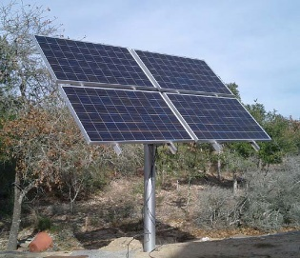(4) Suniva 275W Solar Modules

M250-60-2LL-S22 Micro Inverters

IEMU-03 Energy Management Unit

(5) 240 VAC-P Trunk Cable Connector Kit (ea)

Cable Install Kit (1 End 1 Caps 1 Disconnect

Enphase Engage Coupler

(4) Micro-Inverter Gnd. & Attachment Kits

MN-SPD (Surge Protection Device)

Disconnect 30A

Label Kit

**1.1 kW Kit w/ Roof Mount Kit $3,875.00**

**1.1 kW Kit w/ Pole Mount Kit $4,550.00**

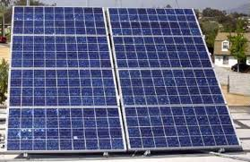**2.2 kW Grid-Tie Kit**

(8) Suniva 275W Solar Panel

(8) M250-60-2LL-S22 Inverter

IEMU-03 Energy Management Unit

(9) Drop 240 V Trunk Cable Connector Kit (ea)

Cable Install Kit (1 End 1 Cap 1 Disconnect)

Enphase Engage Coupler

(8) Micro-Inverter Gnd & Attachment Kit

MN-SPD

Disconnect 30A

**2.2 kW Kit w/ Roof Mount $6,575.00**

**2.2 kW Kit w/ Ground Mount $6,825.00**

**2.2 kW Kit w/ Pole Mount $7,995.00**



**Grid Tie Solar**

**3.3 kW Grid-Tie Kit**

(12) Suniva 275W Solar Panel

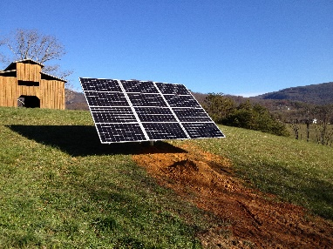(12) M250-60-2LL-S22 Inverter

IEMU-03 Energy Management Unit

(13) Drop 240 V Trunk Cable Connector Kit (ea)

Cable Install Kit (1 End 1 Caps 1 Disconnect)

Enphase Engage Coupler

(12) Micro-Inverter Gnd. & Attachment Kit

MN-SPD

Disconnect 30A

**3.3 kW Kit w/ Roof Mount $9,300.00**

**3.3 kW Kit w/ Ground Mount $9,575.00**

**3.3 kW Kit w/ Pole Mount $10,050.00**

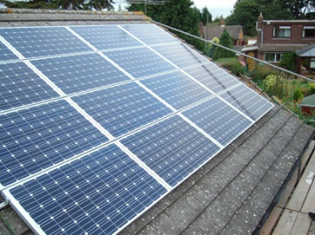**4.4 kW Grid-Tie Kit**

(16) Suniva 275W Solar Panel

(16) M250-60-2LL-S22 Inverter

IEMU-03 Energy Management Unit w/wifi

(17) Drop 240 V Trunk Cable Connector Kit (ea)

Cable Install Kit (1 End 1 Caps 1 Disconnect)

Enphase Engage Coupler

(16) Micro-Inverter Gnd. & Attachment Kit

MN-SPD

Disconnect 30A

**4.4 kW Kit w/ Roof Mount $11,975.00 4.4 kW Kit w/ Ground Mount $12,350.00**

**4.4 kW Kit w/ Pole Mount $14,275.00**



**Grid Tie Solar**

**5.5 kW Grid-Tie Kit**

(20) Suniva 275W Solar Panel

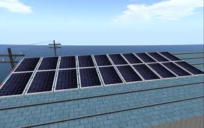(20) M250-60-2LL-S22 Inverter

IEMU-03 Energy Management Unit w/wifi

(22) Drop 240 V Trunk Cable Connector Kit (ea)

Cable Install Kit (1 End 1 Caps 1 Disconnect)

Enphase Engage Coupler

(20) Micro-Inverter Gnd. & Attachment Kit

MN-SPD

Disconnect 30A

**5.5 kW Kit w/ Roof Mount $15,000.00**

**5.5 kW Kit w/ Ground Mount $15,150.00**

**5.5 kW Kit w/ Pole Mount $17,550.00**

**11.0 kW Grid-Tie Kit**

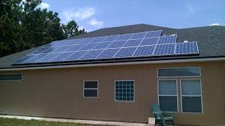(40) Suniva 275W Solar Panel

(40) M250-60-2LL-S22 Inverter

IEMU-03 Energy Management Unit

(44) Drop 240 V Trunk Cable Connector Kit (ea)

Cable Install Kit (1 End 1 Caps 1 Disconnect)

(4) Enphase Engage Coupler

(40) Micro-Inverter Gnd. & Attachment Kit

MN-SPD

Disconnect 60A

**11.0 kW Kit w/ Roof Mount $29,800.00**

**11.0 kW Kit w/ Ground Mount $29,525.00**

**1.10 kW Kit w/ Pole Mount $34,250.00**



**AC Coupled Backup**

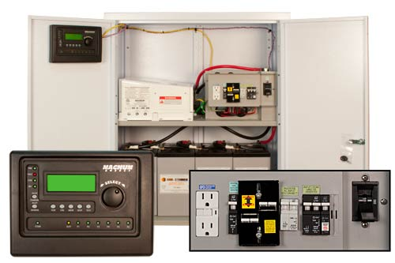**4000 Watt D3R ACC Backup Kit**

Midnite MND3RACCPLM-RSS 4,000 W

24V w/ D3R Battery Enclosure

(4) Battery (US 305 AGM 6V)

4/0 Battery Cable Wiring Kit

**TOTAL $9,190.00**

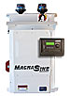

**4000 Watt ACC Backup Kit**

Midnite MNEMS4024PAEACCPL

ACC, 4.0 kW, 24VDC, 120/240VAC

MNBE-D Battery Enclosure

(4) Battery (US 305 AGM 6V)

4/0 Battery Cable Wiring Kit

**TOTAL $8450.00**

**8000 Watt ACC Backup Kit**

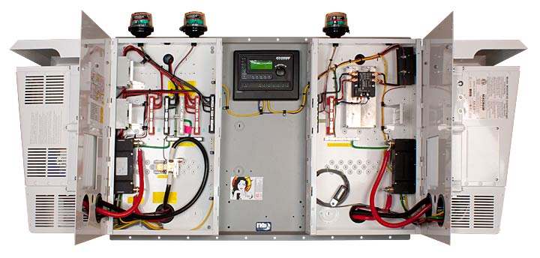Midnite MNEMS4024PAEACCPL-DUAL

ACC, 8.0 kW, 24VDC, 120/240VAC

MNBE-D Battery Enclosure

(8) Battery (US 305 AGM 6V)

4/0 Battery Cable Wiring Kit

**TOTAL $15,450.00**



**Solar HVAC**

**Hotspot Energy ACDC12**

 Save up to 90% on Heating and Cooling!

Designed for low cost, easy installation and a fast payback. This unique solar air conditioning technology requires no batteries, no inverter, no controller - just plug in the solar panels and start saving up to more than 90% on daytime cooling or heating costs.

For home or office use, this system will cool an area for pennies with 90% or more of the energy coming from sunlight. In addition to cooling, the ACDC12b solar heat pump will provide solar powered heating, operating all the way down to an outside ambient temperature of 5F.

**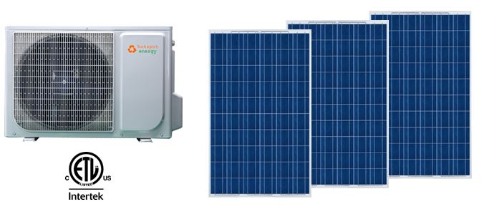**ACDC12b solar air conditioners need no batteries, and only need two or three PV panels to deliver a huge savings. During the day, when air conditioningis needed the most, you can operate this unit with

**ACDC12B IDU (Indoor Unit)**  very little draw on your utility meter. At night, you continue to save due to the >SEER 21 rating on this unit. The mini-split air conditioner design allows you to put solar cooling into the area where it's needed the most and avoid the security issues of an unsightly and noisy window unit. If your location needs heat during the winter, take a full 1-ton of the daytime heating load off of your main heating system and get a head start on evening heating requirements.  And because it's a ductless system, it allows 100% of your heating or cooling to be delivered to where it's needed without the loss that occurs in a ducted system. Note - this is not an "off-grid" unit, 240v utility power is required.

The ACDC12 is installed just like a normal mini-split air conditioner. Once it’s installed you simply connect the solar panels using industry-standard MC4 connectors. You can use 1, 2 or 3 60 cell solar panels for a total of up to 900w., note the panels should be minimum 30v PV panels (30-39v The ACDC12 uses R410a, an ozone-friendly refrigerant, so it is perfectly legal for the customer to self-install however we recommend hiring a professional HVAC installer. If self-installing you will need a vacuum pump to commission the unit.

**Hotspot Energy ACDC12 $1895.00**

**W/ (1) 275W Panel & Mounting Hardware $2390.00**

**W/ (2) 275W Panel & Mounting Hardware $2885.00**

**W/ (3) 275W Panel & Mounting Hardware $3380.00**

**\* Does not Include wire and wiring accessories.**

**Solar HVAC**

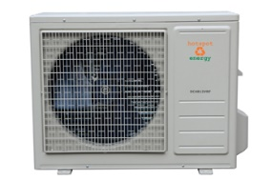

**HotSpot DC4812VFR Air Conditioner**

**12,000 BTU DC Air Conditioner for Off-Grid Solar & Telecom Applications**

If your power source is native 48VDC (or -48VDC) as part of a telecom or off-grid solar application, HotSpot

Outdoor Unit (ODU) DC4812VRF all-DC air conditioners are your most efficient

cooling choice. DC48 air conditioners can substantially DC system means you get the advantage of extreme high efficiency without the need for inverters.

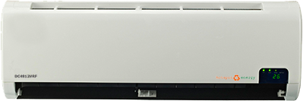The HotSpot DC4812VRF is a purpose-built DC powered air conditioner heat pump for native DC power. It's designed to conserve power, and operate reliably for many years without maintenance.

The DC4812VRF is a variable capacity, variable speed, variable refrigerant flow unit. There is no other solar or DC air conditioner like it on the market. Indoor Wall Mount Unit (IDU)

**DC4812VFR Air Conditioner $2285.00**

**Climax VS12 Portable Air Conditioner 12,000 Btu**

Worlds Most Efficient Portable Air Conditioner

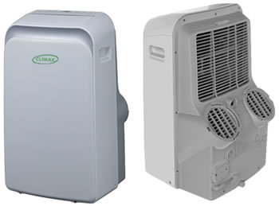

**Uses 50%**

**Less Electricity ~ Get TWICE the COOLING On a Hot Day**

UL 484 / CSA 22.2 / TUV Certified by California Energy Commission

Climax is the first-ever portable air conditioner with a DC Inverter Compressor, it saves 30-40% in operating power costs while running quieter and lasting much longer than any other portable. The Climax DC Inverter AC unit can speed up or slow down to precisely match the cooling load and avoid wasteful on-off cycling. The Climax portable is always exactly the right size for the job.

**VS12 Portable AC $ 999.00**

**Solar Power Storage**

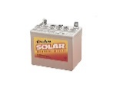**8AU1H AGM Battery**   
32.5 Amp Hours 12 Volt  
L 7.75" W 5.13" H 7.25" **$89.00**

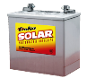**8A22NF AGM Battery**

55 Amp Hours 12 Volt

L 9.38" W 5.50" H 9.25" **$159.00**



**8A24DT AGM Battery**

79 Amp Hours 12 Volt

L 10.25" W 6.75" H 9.88" **$209.00**

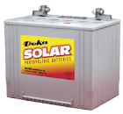**8A27DT AGM Battery**

92 Amp Hours 12 Volt

L 12.75" W 6.88" H 8.63" **$249.00**

**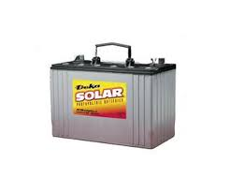**

**8A31DT AGM Battery.**

105 Amp Hours 12 Volt

L 12.94" W 6.75" H 9.38" **$279.00**

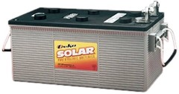**8A4DLTP AGM Battery.**

200 Amp Hours 12 Volt

L 20.75" W 8.50" H 10.00" **$499.00**

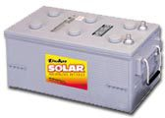

**8A8DLTP AGM Battery.**

245 Amp Hours 12 Volt

L 20.75" W 11.00" H 10.00" **$599.00**

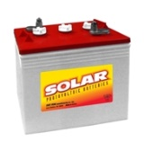

**8AGC2 AGM Battery.**

200 Amp Hours 6 Volt

L 10.25" W 7.13" H 10.88" **$279.00**

[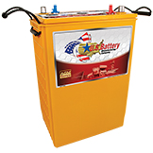](http://usbattery.com/products/us-agm-batteries/us-agm-l16/)**US Battery 305 AGM**

312 Amp Hours 6 Volt

L 11.61” W 7.09” H 14.41” **$519.00**

**Solar Lighting**

**NATURAL LIGHT Tubular Skylights**

**10" Tubular Skylight Kit**  **$279.00**

Natural lighting for areas up to 150 sq. ft. Equivalent of up to 300 watts output. Includes: 4’ Light Pipe, trim ring, diffuser and hardware kit. Available with Grey or Black flashing.

**13" Tubular Skylight Kit $359.00**

Natural lighting for areas up to 300 sq. ft. Equivalent of up to 500 watts output. Includes: 4’ Light Pipe, trim ring, diffuser and hardware kit. Available with Grey or Black flashing.

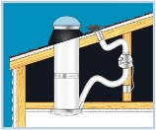 **10"** **Super Vent Fan (SVF).** **$425.00**

Add a 125 cfm Vent Fan to your Natural Light Tubular Skylight!

**Remote Control Dimmer Kit $235.00**

**(For 10” and 13” Models)**  The dimmer allows you to adjust the amount of daylight entering a room with an

easy-to-use remote control.



**18" Tubular Skylight Kit $499.00**

**(Commercial)**  
Natural lighting for areas up to 500 sq. ft. Equivalent of up to 1000 watts output. Includes: 4’ Light Pipe, trim ring, diffuser and hardware kit. Available with Grey or Black flashing.

**21" Tubular Skylight Kit $629.00**

**(Commercial)**  
Natural lighting for areas up to 700 sq. ft. Equivalent of

up to 1450 watts output. Includes: 4’ Light Pipe, trim

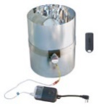 ring, diffuser and hardware kit. Available with Grey or

Black flashing

**18” Remote Control Dimmer Kit $278.00**

**21” Remote Control Dimmer Kit $318.00**

**Solar Accessories**

**NATURAL LIGHT Tubular Skylights**



**Light Kit**. **$36.00**

There may be instances where a room is either too small or it is otherwise undesirable to have a second light fixture in the ceiling.

|  |  |  |
| --- | --- | --- |
| **Solar Attic Ventilators** | | |
| 20100_1 | **12W Solar Attic Fan** A single 12 watt unit can fully vent up to 1,200 square feet, operating at up to 850 cfm. Available in Grey or Black. | **$389.00** |
| 20100_1 | **24W Solar Attic Fan** A single 24 watt unit can fully vent up to 2,000 square feet, operating at up to 1275 cfm. Available in Grey or Black. | **$499.00** |
| 20230_1 | **36W Solar Attic Fan** A single 36 watt unit can fully vent up to 2,500 square feet, operating at up to 1550 cfm. Available in Grey or Black. | **$579.00** |
| Description: http://www.sunvoltenergy.net/ProductImages/20235_1.jpg | **50W Solar Attic Fan** A single 50 watt unit can fully vent up to 3,100 square feet, operating at up to 1900 cfm.Available in Grey or Black. | **$759.00** |
| Description: http://www.sunvoltenergy.net/ProductImages/20255_1.jpg | **Garage/Building Exhaust Vent Kit** The garage vent kit converts a roof or curb mount solar attic fan into a garage venting system. | **$129.00** |
| Description: http://www.sunvoltenergy.net/ProductImages/20256_1.jpg | **Radiation Damper (Optional)**  Required in some locations to protect against fire and heat radiation (check local building codes). | **$59.00** |

**Solar Accessories**

|  |  |  |  |  |  |  |
| --- | --- | --- | --- | --- | --- | --- |
| 20300_1 | **12W Solar Attic Fan – Gable/Wall Mount**  A single 12 watt unit can fully vent up to 1,200 square feet, operating at up to 850 cfm. | | | | **$389.00** | |
| 20300_1 | **24W Solar Attic Vent – Gable/Wall Mount** A single 24 watt unit can fully vent up to 2,000 square feet, operating at up to 1275 cfm. | | | | **$499.00** | |
| 20300_1 | **36W Solar Attic Vent – Gable/Wall** **Mount**  A single 36 watt unit can fully vent up to 2,500 square feet, operating at up to 1550 cfm. | | | **$579.00** | | |
| 20300_1 | **50W Solar Attic Fan - Gable/Wall Mount** A single 30 watt unit can fully vent up to 2,500 square feet, operating at up to 1550 cfm. | | | **$759.00** | | |
| Description: http://www.sunvoltenergy.net/ProductImages/20450_1.jpg | **Thermal Snap Switch** Designed to keep your Natural Light Solar Attic Fan from operating when your attic temperature is 70˚ F or below. | | **$19.50** | | |
| Description: http://www.sunvoltenergy.net/ProductImages/20451_1.jpg | **Fire Safety Cut Off Switch** Designed to help stop the spread of house attic fires during daytime fan operation by shutting down the fan. | | **$19.50** | | |
| NL%20Eco%20Product | | **Attic venting is an important aspect in maintaining a healthy energy efficient home.** Proper venting cools your roof extending the material life and reduces the load on your air conditioning system. Attic venting also increases fresh air circulation which reduces vapor build up generated by every day activities like showering and cooking. | | Tax%20Credit | | |

**Solar Hot Water System Kits**

**These Drainback system are designed for a 40 - 52 gal existing or conventional water heater.**

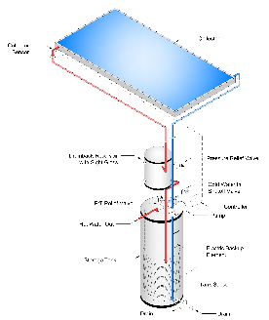

**DX-R-26 DX System Kit**

1 AE-26 Collector w/ FLUSH Mounts

1 DB-10-10XC 10 GAL SS RESERVOIR W/10 SQ.FT. HEAT EXCH

1 UP15-100F GRUNDFOS CAST IRON HIGH HEAD PUMP

1 F-GF1526 3/4" NPT CAST IRON FLANGE SET

1 UP15-10SU7P GRUNDFOS STAINLESS CIRCULATION PUMP

1 DTC-ES-1C EAGLESUN DIFF CONTROL W/ READOUT & 2 SENSORS

1 BD-75 3/4" BOILER DRAIN

1 WH-TM24 WATER HEATER TIMER

**TOTAL $2490.00**



**DX-R-32 DX System Kit**

1 AE-32 Collector w/ FLUSH Mounts

1 DB-10-10XC 10 GAL SS RESERVOIR W/10 SQ.FT. HEAT EXCH

1 UP15-100F GRUNDFOS CAST IRON HIGH HEAD PUMP

1 F-GF1526 3/4" NPT CAST IRON FLANGE SET

1 UP15-10SU7P GRUNDFOS STAINLESS CIRCULATION PUMP

1 DTC-ES-1C EAGLESUN DIFF CONTROL W/ READOUT & 2 SENSORS

1 BD-75 3/4" BOILER DRAIN

1 WH-TM24 WATER HEATER TIMER

**TOTAL $2650.00**

**These Drainback system come with a new conventional solar storage tank with a 4500W element for backup.**



**DX-65-42 System Kit**

2 AE-21 Collectors w/ FLUSH Mounts

1 DB-10-10XC 10 GAL SS RESERVOIR W/10 SQ.FT. HEAT EXCH

1 UP15-100F GRUNDFOS CAST IRON HIGH HEAD PUMP

1 F-GF1526 3/4" NPT CAST IRON FLANGE SET

1 UP15-10SU7P GRUNDFOS STAINLESS CIRCULATION PUMP

1 DTC-ES-1C EAGLESUN DIFF CONTROL W/ READOUT & 2 SENSORS

1 BD-75 3/4" BOILER DRAIN

1 OST-65TSC W/ 65 GAL SOLAR STORAGE TANK

**TOTAL $3950.00**

**Solar Hot Water System Kits**



**DX-80-64 System Kit**

2 AE-32 Collectors w/ FLUSH Mounts

1 DB-10-10XC 10 GAL SS RESERVOIR W/10 SQ.FT. HEAT EXCH

1 UP15-100F GRUNDFOS CAST IRON HIGH HEAD PUMP

1 F-GF1526 3/4" NPT CAST IRON FLANGE SET

1 UP15-10SU7P GRUNDFOS STAINLESS CIRCULATION PUMP

1 DTC-ES-1C EAGLESUN DIFF CONTROL W/ READOUT & 2 SENSORS

1 BD-75 3/4" BOILER DRAIN

1 OST-80TSC W/ 80 GAL SOLAR STORAGE TANK

**TOTAL $4590.00**



**DX-120-80 System Kit**

2 AE-40 Collectors w/ FLUSH Mounts

1 DB-10-10XC 10 GAL SS RESERVOIR W/10 SQ.FT. HEAT EXCH

1 UP15-100F GRUNDFOS CAST IRON HIGH HEAD PUMP

1 F-GF1526 3/4" NPT CAST IRON FLANGE SET

1 UP15-10SU7P GRUNDFOS STAINLESS CIRCULATION PUMP

1 DTC-ES-1C EAGLESUN DIFF CONTROL W/ READOUT & 2 SENSORS

1 BD-75 3/4" BOILER DRAIN

1 OST-120TSC W/ 120 GAL SOLAR STORAGE TANK

**TOTAL $5250.00**

***SunVerter*™ e-Tube Glycol Pressurized System**

[no<br>image](http://www.sunvoltenergy.net/index.asp?page=ProductDetails&Item=10903)**SunVerter™ E-Tube 2000B Packaged Solar Water Heating System**

This Basic Kit includes a SOLUS™ 20 Tube Collector,

STM-220X and the basic components required for

installation using your own piping, insulation and fittings.

**TOTAL $2990.00**

[no<br>image](http://www.sunvoltenergy.net/index.asp?page=ProductDetails&Item=10903)**SunVerter™ E-Tube 3000B Packaged Solar Water Heating System**

This Basic Kit includes a SOLUS™ 30 Tube Collector,

STM-220X and the basic components required for

installation using your own piping, insulation and fittings.

**TOTAL $3450.00**

**Solar Pool Heaters**

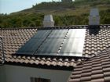EagleSun - 4'x12' Professional Quality Solar Pool Panel w/ 2" Header.

**ES-48P** **$240.00**

EagleSun - 4'x10' Professional Quality Solar Pool Panel w/ 2" Header.

[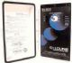](http://www.sunvoltenergy.net/index.asp?page=ProductDetails&Item=40260)**ES-40P** **$224.00**

EagleSun - 4'x8' Professional Quality Solar

Pool Panel w/ 2" Header.

**ES-32P** **$208.00**

Eagle Sun 2" Panel Kit (1) per Panel **ES-PK2 $36.00**

Eagle Sun 2" System Kit (1) per System **ES-SK2 $60.80**

Eagle Sun 2" Split/Row Spacer Kit **ES-SRK2 $60.80**

EagleSun 2" Vacuum Breaker Kit (1) per System **ES-VB7K $43.20**

Poly Strap 100' Roll (3 straps per panel) **ES-STRAP100 $51.20**

**GOLDLINE GLC-2P Solar Pool Heating Control Combo Pack** **$495.00**    
ES-GL235 $330.00Goldline Control Auto Kit w/ 3 way valve

**In Ground Pool Collector Sizing**

The "rule of thumb" for sizing a swimming pool solar heating system 60% to 80% of the pool's surface area in solar panels. For example, a 480 square foot pool (32 feet by 15 feet) needs 288 to 384 square feet of solar panel area.

**HotSpot FPH Heat Recovery Pool Heater**

Extend your swimming season to match your air conditioning season with zero pool heating costs. The FPH converts your standard AC into a water-source geothermal type system, saving up to 40% on air conditioning costs. Automatic programmable thermostat controller monitors the pool temperature and activates the pool pump/heat recovery when heat is needed to maintain the desired pool temperature. Operates day or night, rain or shine. Only 6-8 hours per day of normal AC operation can heat a standard home pool. Can be installed in less than a day by an experienced local HVAC contractor. For residential or commercial air conditioners.

**$495.00**

**Solar Water Pumping**

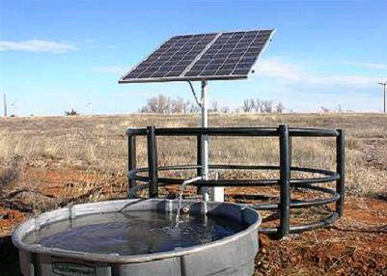

**Solar Water Pumping Kit**

Stand Alone 24V

*Pump Water when the sun shines!*

Kit includes:

(1) 200 Watt Solar Module

(1) SolaTOP Pole Mount

(1) SunPumps PCA-30 Controller

(1) Basic Wiring Kit \*

(1) SunPumps Submersible Pump

Choice of one:

SDS-T-128 (1.75 GPM @ 250’ TDH)

SDS-T-130 (2.25 GPM @ 180’ TDH)

SDS-T-135 (2.75 GPM @ 130’ TDH)

Fits in 4” Well or can be used in a cistern.

**$1550.00**

\* Does not include wire between pump &

controller.

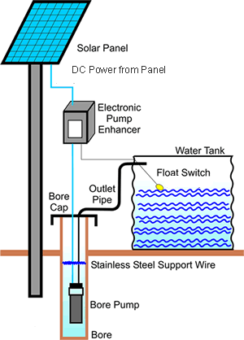

Great for irrigation or for livestock watering. Higher volume and battery storage systems available. Adding battery storage will allow operation on cloudy days or at night. Financing and installation available. Qualifies for Federal 30% Renewable Tax Credit. Call or e-mail for more information.

Solar Pumps available for any application, contact us for a quote.

***The EnergyStore***

Renewable Power Supply

4421 Cherry Street, Suite #20

Winston-Salem, NC 27105